**Data Warehouse**

* Centralize
* Integrate in one place different databases
* For reports, data analysis
* Easy navigation
* Fast query structure
* Inside are **Data Marts** (sub set of each Database source)

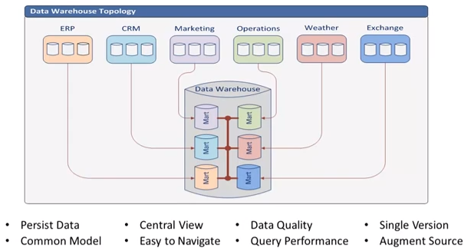

|  |  |
| --- | --- |
| **Fact table** | **Dimension table** |
| - Containing measurements  - Grain defined by related dimensions  - Usually additive, but not always  - To resolve many-many relationships | - Containing business elements  - Contain element descriptions  - Referenced by multiple fact tables  - Replaces codes with business terms |

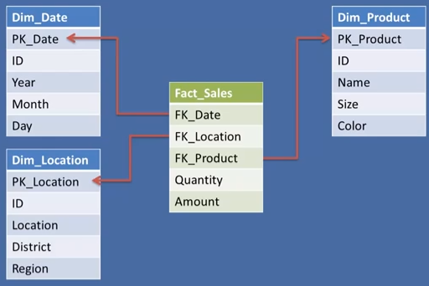

**SLOW CHANGING DIMENSION ( SCD )**

* Dimension that changes over time
* Industry standard SCD types

**INITIAL DATA LOADED**

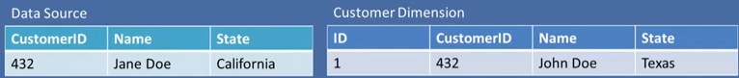

**SCD TYPE 0**: If the Data Source changes (name / state) but we don’t change Customer Dimension

**SCD TYPE 1**: If the Data Source changes (name / state) AND we update information in Customer Dimension

In SCD TYPE 1 WE DON’T TRACK THE HISTORY

In SCD Type 2 we include

* **ID**
* **Effective**
* **Expired**
* **Current**

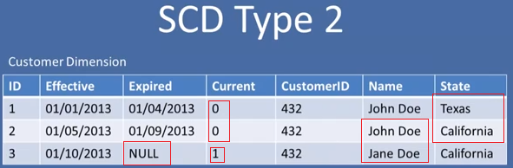

We can create a HYDRID,

* If the name changes, it changes ALL rows
* If the state changes, add a new row

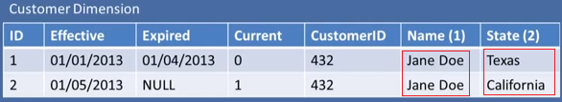

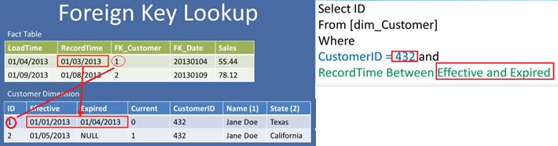

**Types of keys**

* Business, natural, dimension ( CustomerID, EmployeeID)
* Primary, candidate, alternate (Any field who may be unique, CustomerID, Name if none is repeated )
* Composite, compound, concatenated ( Keys made by several fields to make them unique)
* Surrogate: Key with no business mean, and usually autogenerated ( Row_ID )
* Foreign: Key that points out to another primary key in another table

**UNKNOWN MEMBER**

The customer 521 doesn’t exist, so we create in Customer Dimension and entry with name “Unknown” and then we create a reference to Fact Table with value “-1” means “Unknown member”

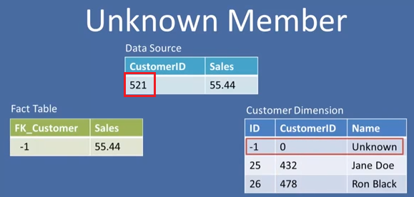

**INFERRED MEMBER**

We don’t know the name, but we create everything expecting in the future to update the name, and in the meanwhile the Inferred field will be set to “1” to know who is still missing.

